

**HIGHLAND RFCA CHAMBERFORCE PROJECT – FINAL REPORT**

References:

1. ChamberFORCE Project Management Plan dated 8 Jan 18.
2. RF&C/EE/SLA between CDP and CE RFCA 2018 dated 27 Mar 18.
3. ChamberFORCE Business Case dated 31 Aug 18.
4. Defence People EE Strategy (DPEES) dated 8 Jan 19.
5. Defence People EE Directive (DPEED) dated 8 Jan 19.
6. Forces in Mind Trust Report - *Armed Forces Covenant – Benefit not Burden* 2018.

**Executive Summary**

1. During the period 2017-2018, Highland RFCA (HRFCA) implemented a review of engagement with Chambers of Commerce operating in its area of responsibility, in order to determine mutual efficiency and Return on Investment (RoI). This review led to the creation of an Executive Group of five Chambers who, after further scoping, agreed to be founder partners in a new initiative, branded ChamberFORCE. A unique element of ChamberFORCE is a ‘buddy’ system through which each of the participating Chambers is partnered with a named military counterpart. These personnel also became members of the Executive Group which met quarterly to report on progress. The initiative was launched as a 12-month pilot in Nov 18, sponsored by Defence Relationship Management (DRM) and managed by HRFCA. The aim of the initiative was to simplify and streamline engagement between Defence and Chambers as key business stakeholders, leading to a better RoI for all and improved achievement of DRM outputs. This report outlines the background to the initiative and development of a pilot project. It defines aims, analyses outcomes and provides statistical evidence of progress against objectives and agreed milestones. Key findings are as follows:

1. The pilot project found that the concept of having a named military ‘buddy’ successfully reduced previous confusion over who was the correct military Point of Contact (PoC) with which Chambers of Commerce should engage, and created a defined handover process for incoming military PoCs.
2. A survey sent out biannually to members of participating Chambers found a significant increase in both business awareness of, and willingness to sign up to, the Armed Forces Covenant (AFC) compared with the wider business community.
3. Creating an identifiable brand and implementing a communication strategy across all the partners gave HRFCA a vastly increased target audience for DRM messaging using a range of social media platforms and hard copy promotions.

2. The Report concludes that all members of the Executive Group considered the pilot project to have demonstrated success, while identifying areas for further development which did not reach maximum potential within the 12-month period of the project. One of the original Chambers withdrew at the end of the pilot project, citing the need to focus more on economic areas of priority for their region (Aberdeen). Two other Chambers expressed a desire to join the programme (Inverness and Ayrshire), and the Scottish Chambers of Commerce are now discussing their capacity to manage the project at a national level. The pilot has evidenced the need for further funding so that ChamberFORCE can be further developed into a national strategy to support the mutual benefits of military and commercial engagement. The next phase (Phase 2) will incorporate addressing the skills shortages in the Scottish economy by highlighting the transferable skills of Reservists, Veterans and Cadet Adult Volunteers and the benefits these bring to the world of commerce.

**Background**

3. The ChamberFORCE pilot project was launched by Highland RFCA (HRFCA) in Dundee on 21 Nov 18. It was conceived as a collaborative partnership between five Chambers of Commerce in the Highland RFCA (HRFCA) area and a range of military partners from all three single Services; these are set out at Annex A. Between them, the five Chambers involved in the partnership have 2,695 businesses as members and an extensive following on social media of both members and non-members.

4. Purpose. The stated purpose of the pilot project as articulated in the Project Management Plan at Reference A and at Enclosure 1 was **‘to simplify and streamline engagement between Defence and Chambers as key business stakeholders, leading to a better Return on Investment (RoI) for all, and improved achievement of DRM outputs.’** These reflect Defence Relationship Management (DRM) outputs as set out in the Service Level Agreement (SLA) at Reference B, including: progress in the Employer Recognition Scheme (ERS); raising awareness of Defence People and their skills; securing long term mutually-beneficial relationships; and promoting the active recruitment by employers of Reservists, Service Leavers, Veterans, Service Spouses, Cadet Force Adult Volunteers (CFAV) and Wounded, Injured and Sick (WIS). From a Chamber of Commerce-specific perspective, desired outcomes to be achieved through project outputs included: a clearer understanding of Defence and the roles of Reservists; simplified engagement, access to key events and benefits to members; and promotion of the Chambers via HRFCA networks and social media activity.

5. Achievement of Objectives. The DRM and ChamberFORCE outputs identified would be achieved through a variety of deliverables, ranging from bespoke activities such as business breakfasts, unit visits and civic engagements organised by the Project stakeholders comprising the five participating Chambers, their military partners, and HRFCA, to the utilisation of scheduled military events including gun salutes and ship visits. These are detailed in the Project Management section of this Report, beginning at paragraph 13, and evidenced chronologically at Annex C.

**Concept of Project**

6. The Project was predicated on the fact that Chambers of Commerce play a key role in Employer Engagement (EE) in Scotland, both through the national body – the Scottish Chambers of Commerce are ERS Silver Award Holders - and through the various regional Chambers, most of whom have signed the Armed Forces Covenant (AFC) and hold ERS Bronze, Silver or Gold awards. Because of the geographical challenges posed to Regional Employer Engagement Directors (REEDs) by the size and low average population density in the HRFCA area for which they have responsibility, the Chambers are vital in enabling contact with businesses scattered over remote areas. The 23 Chambers in Scotland are generally supportive of both HRFCA and Lowland RFCA (LRFCA) but there is no single strategy for engagement. HRFCA has for a considerable time been a member of 8 different Chambers with whom it has worked on an ad hoc basis as needs arise; an analysis of existing Chambers’ memberships suggested that the opportunities and benefits on offer had not always been fully realised. By reviewing and better aligning the relationship with Chambers, HRFCA stood to increase coordination and cooperation, thus avoiding the need for multiple memberships and generating a better RoI.

7. Chamber Perspective. Chambers themselves reported frustration at the multiple requests for support being made of them by the Defence community. This included RFCAs, individual units and other representatives of the Single Services, military charities, the Career Transition Partnership and others. They found it impossible to distinguish between the various units and organisations, and therefore admitted they were not fully aware of the benefits of engaging with Defence and thus not well equipped to articulate the “What’s in it for me?” message for their members. Not having a clear point of contact was creating misinformation and misunderstanding, and therefore the desire to respond to HRFCA’s engagement requests dropped down the Chambers’ agenda.

8. Single Service Perspective. From a Single Service perspective, units and other military formations in HRFCA’s area have found it difficult to ‘break into’ some areas of the business community around them in order to have the opportunity to deliver positive messaging around the Reservist skills training available to employees and the subsequent benefits to employers. They had individually and collectively identified a need for *‘a good single point of contact for both the Chambers of Commerce and the various military units to develop effective links within the local communities, especially the local business community’* (Regional Business Manager 1 NRCSNI). As part of the scoping and initial research for the project, the concerns of HRFCA, Chambers of Commerce and Defence as set out above were collated and analysed to produce an agreed action plan and way forward which could offer benefit to all of the key stakeholder organisations, and their members and personnel.

9. Agreed Strategy. Following desk/telephone research, participating Chambers’ stakeholders took part in a round table meeting in Apr 18 to agree actions and timelines. Further discussions took place both individually and collectively over several months and the agreed strategy and Business Case at Reference C were submitted to DRM in Aug 18. The Business Case was approved in Sep 18.

**Project Definition**

10. Participating Chambers. Five Chambers in the Highland RFCA area of responsibility were invited to be part of the initial pilot project. These Chambers were selected based on their engagement and commitment to date, and although not the largest Chambers, they were, and are, among the most proactive ones, collectively covering a significant proportion of the HRFCA geographical area. All five had signed the AFC and were ERS award holders. The membership of each of the five participating Chambers is drawn from 11 of Scotland’s local authority areas, stretching from Highland to Inverclyde, covering a combined area of 19,857 square km, and with a collective population of 1,585,300. (Ref 2011 Census). The Chambers have a combined membership of 2,700 businesses with an estimated total of 244,000 employees; this represents significant regional reach, and therefore influence. The areas covered by the five participating Chambers are illustrated at Figure 1 below.

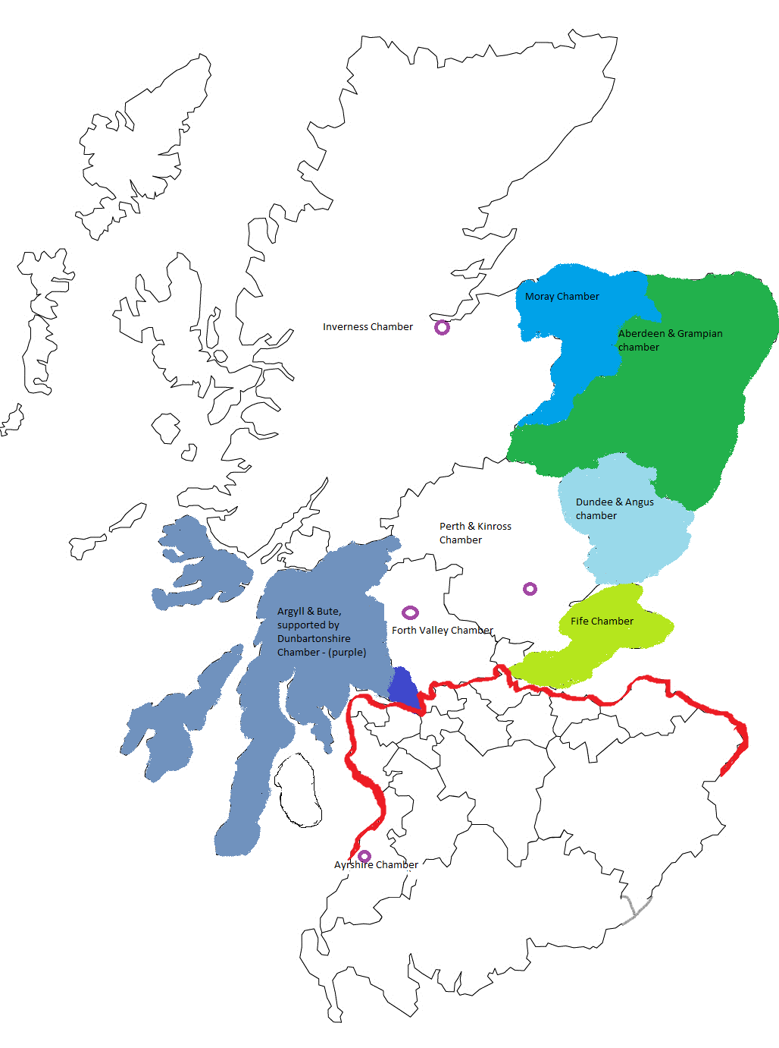

Fig 1. Map showing geographical boundaries of participating Chambers (coloured). The red line shows delineation of boundary between Highland and Lowland RFCA areas of responsibility. Indications of other Chambers expressing interest in ChamberFORCE Phase2, shown by 

11. Military Partners. Each Chamber was allocated a military partner or ‘buddy’ – an essential component of the ChamberFORCE model - and these were identified and selected for the project based on geographical proximity, Defence footprint and an agreed willingness to participate. The buddies were named individuals, representing their wider units and chain of command. As stated above, the five Chambers and their respective military buddies, together with HRFCA, represent the main project stakeholders. DRM was consulted at the Project Concept stage and was asked to sponsor the project for the 12-month pilot period to test the concept.

12. Four Step Project Model. Figure 2. depicts the simple 4 step model used, with all steps based on the core activity of knowledge transfer and peer networking.

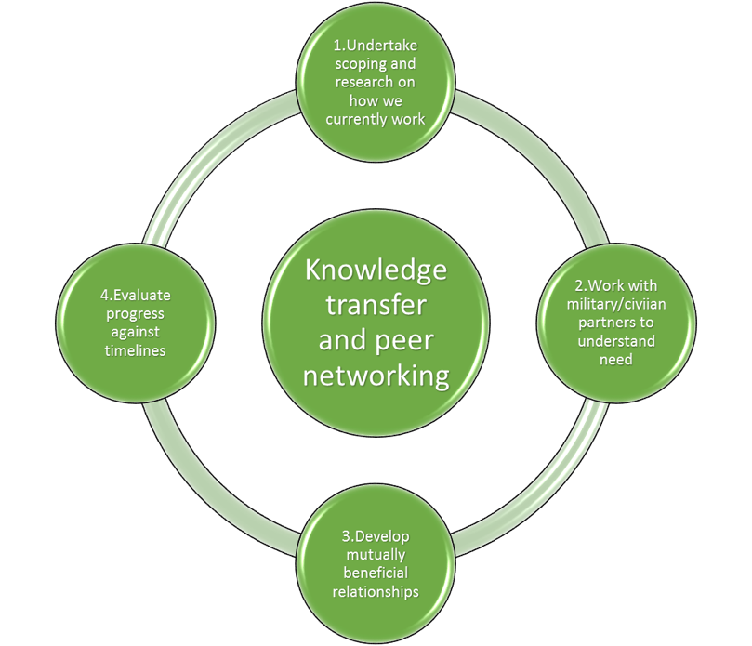

Fig 2.

13. Agreed Actions. Ten actions were agreed to form the basis of the project partnership and would be evaluated as part of this Final Report. These are as follows:

* (1) Each Chamber would identify a single Point of Contact (PoC) to attend quarterly Executive Group (EG) meetings hosted by HRFCA, either in person or remotely where possible. This did not need to be the Chambers’ Chief Executives – any Chamber member of its management team selected as the primary Armed Forces contact was acceptable. Each Chamber’s Armed Forces ambassador would be invited to become an associate member of HRFCA, with the networking opportunities that brought.
* (2) Each Chamber would host a linked webpage outlining the benefits of engaging with Defence – content and financial resources to be provided by HRFCA.
* (3) Each Chamber would send regular e-shots to their respective memberships – content and financial resources to be provided by HRFCA.
* (4) Each Chamber would stock hard copy promotional materials provided by HRFCA/DRM for distribution at events
* (5) Each Chamber would be partnered with a ‘buddy’ military unit with whom they could develop a relationship unique to the identified requirements of their own Chamber membership. This partnership was a key element of the project and would alleviate the problem of multiple requests for support which Chambers have suffered previously.
* (6) Chambers and the HRFCA would commit to actively supporting each other on social media with ‘retweets’, ‘follows’ and ‘likes’ for mutual promotion. HRFCA would encourage its business contacts to engage with their local Chamber if they did not already do so.
* (7) HRFCA would produce a ‘menu’ of offerings and benefits including leadership training, events and speakers, so that Chambers could be informed and be up to date on what HRFCA offers.
* (8) Chambers and HRFCA would jointly produce a Master Events List (MEL) to provide advance notice of events and reduce diary conflictions.
* (9) Chambers represented in the EG would be offered preferential access to those major Defence activities coordinated or hosted by HRFCA.
* (10) New marketing materials produced by HRFCA around employer engagement benefits would carry the branding and logos of participating Chambers.

**Project Management**

14. Outputs. Defence outputs were aligned with the Defence People Strategy and Directive at References D and E respectively and are both qualitative and quantitative. Key amongst these were raising awareness of Defence People issues and developing and securing long-term relationships in the business community. All outputs were identified and agreed during the scoping and research period in consultation with participating Chambers, as set out in the Concept of Project section at paragraph 5 above.

15. Monitoring Progress. Progress in achieving the aims and actions of the Chamber Force pilot project was measured via quarterly meetings with the project EG comprising all stakeholders, and through regular feedback, reports and surveys, the latter referred to at paragraph 23 below. Social media analytics were monitored and recorded by the HRFCA Engagement Team. The existing Salesforce Measures of Effectiveness (MoE) feature was used as a recording mechanism for new AFC signings, progress up the ERS *Ladder of Support* and event attendance. A survey mirroring that sent out by the Force in Mind Trust (FiMT) as part of their *Armed Forces Covenant – Benefit not Burden* report (Reference F) was sent out by the five Chambers to their membership during the first quarter of the project, and then again during the final quarter. An additional question requesting contact details for those expressing an interest in the AFC was added to the second survey in line with the requirements of the 2018 General Data Protections Regulations (GDPR). It was agreed that the EE team at the Army’s Regional Point of Contact (RPoC) Bde in the HRFCA area (51 Inf Bde) would be kept informed of the progress of the pilot via the Regional Employer Engagement Board (REEB) Working Group meetings, and at the REEB itself, where the HRFCA Head of Engagement (Hd Eng) would provide a verbal update. Copies of the interim report (including minutes of all meetings) would also be made available to all parties. Throughoutthe duration of the project, military buddies also engaged directly with HRFCA, providing input and updates. Finally, LRFCA, as the second Scottish RFCA, was kept fully informed via team meetings and bilateral discussions between respective Hds Eng. Hd Eng LRFCA was invited to attend the final quarterly meeting of the EG in an observer capacity.

**Project Deliverables**

16. Actions Achieved. The achievement of the project outputs identified at Reference A and in accordance with Reference B, was assessed in the context of the ten agreed actions set out at paragraph 12 above. Of these, a number were assessed as fully successful, and in particular:

1. The **first** (establishing routine working relationships between HRFCA and participating Chambers); of the participating Chambers, four accepted the offer to become Associate Members of HRFCA, representing an 80% uptake and bringing enhanced knowledge of the commercial world in which Reservists operate to the wider HRFCA membership. Furthermore, the President of the Scottish Chambers of Commerce (SCC) accepted an invitation to join the HRFCA membership as a Representative Employer member.
2. The **fifth** (creating and sustaining the military buddy relationship) proved pivotal in pursuing the agreed outputs.
3. The **second** (hosting linked webpages) also proved to be very successful as a cost-effective way to use Chambers as, in effect, force multipliers.
4. The **sixth** (proactive use of social media) allowed the pilot to promote Defence to a very large combined Facebook and Twitter audience. See Paragraph 21 below for statistics.
5. The **fourth** (use of hard copy promotional material), **seventh** (menu of benefits), **ninth** (access to Defence activities) and **tenth** (inclusion of Chambers’ branding and logos), were also implemented and proved workable and beneficial.

17. Actions Not Fully Achieved. Two of the agreed actions were not fully achieved, as follows:

1. The **third** agreed action (use of e-shots) was less successful; it was felt that Chambers needed to balance their messaging to members and that their primary role was to advise business members on matters of commerce, business finance and legislation, with too many e-shots on Defence matters potentially causing confusion and alienating some members. Therefore individual Chambers chose when to send out information to fit in with other bulletins and newsletters. The only e-shots which went out uniformly across all Chambers were the surveys referenced at paragraph 23 below. Chambers promoted the project via their own internal comms platforms using existing publications, rather than sending Defence specific e-shots. This finding reflects the comments made at the scoping stage that all Chambers were different with varying demographics and target audiences, so messaging that was ‘one size fits all’ would not be successful.
2. The **eighth** (creation of an MEL); while all parties were keen to do this it proved difficult to co-ordinate with so many parties involved. It was challenging for both Chambers and military buddies to identify which events may be of interest, and factors such as operational impacts on events including ship visits, as well as the emergence of Brexit-related priorities for Chamber events meant that the MEL quickly became inaccurate. Long-term forecasting of events and activities also proved difficult to manage. Although a MEL was created initially, it lapsed as the project progressed.

18. Extent of Events Delivered. A wide range of ChamberFORCE branded events took place over the 12-month period of the project, organised between the buddies in each partnership. These included business breakfasts, visits to Royal Navy, Army and Royal Air Force bases and training areas, leadership and training activities, and various ship visits involving Reception and Capability Demonstrations (RCD). The events brought together military and civic participants, generating many opportunities to promote the AFC and ERS, as well as highlighting the benefits of employing Reservists. The work of the buddies in achieving this significantly helped the HRFCA EE team in terms of workload, offering greater reach and introductions to new companies. Several AFC signings were directly generated by these events; for example the promotion by Dunbartonshire Chamber of the ChamberFORCE project at its annual business awards, led to a local employer, Glenhead Engineering, signing the AFC the following month, while a ship visit arranged with Aberdeen Chamber members served to initiate a positive relationship with employer Global Energy Group, who will also sign the Covenant this year.

19. Exercise ChamberSTRETCH. Among the most complex and successful of ChamberFORCE events delivered was the inaugural Exercise ChamberSTRETCH, arranged between 225 Med Regt and Dundee & Angus Chamber of Commerce, and taking place on Reserves Day 19. The Exercise was based on the Exercise EXECUTIVE/MINI STRETCH model, the main difference being that the Chamber was able to exert influence to have the event hosted in public and not ‘behind the wire’ at a military establishment. This allowed a high level of visibility for the general public, and Dundee City Council granted free use of the city-centre Slessor Gardens site as part of their ERS Gold Award recipient commitments. This had an in–kind value of £1,000. The Chamber also managed the administration and guest list, again relieving HRFCA of this element of the normal workload. Sixty business participants, both owners and employees, undertook a day of leadership challenges led by 225 Med Regt personnel and with other units providing real-life support, and this generated a huge amount of publicity and very positive feedback. The Administrative Order and organisation details for this event have been made into a template which is now available for all participating Chambers and there are plans to hold more ChamberSTRETCH exercises across Scotland. A full list of key engagement events and activities is at Annex C.

20. Participation in Events. While it is not possible to estimate exact numbers of businesses at ChamberFORCE events (some businesses will have attended more than one, or sent several delegates from one company), it is estimated that over 200 businesses have been exposed directly to the ChamberFORCE messaging via events. Some 460 guests from 170 businesses attended the SCC Annual Address in Glasgow in Sep 19 to hear CEO Dr Liz Cameron OBE talking about the project, welcoming military buddies who attended in uniform, and stressing to the business community that working with Reservists was a positive way to attract skilled members of staff and address the current skills shortages in Scotland.

21. Communications Activities. A Project Communications Plan was produced (Annex D), which included a ChamberFORCE webpage hosted on the HRFCA website; a template was sent to participating Chambers, who all added this page to their existing websites. Core messaging was constant between all of the sites, with each Chamber able to adapt the wider narrative to suit their own membership and geographical area, including for example case studies which featured local businesses employing Reservists, or mention of events and activities in the individual Chamber areas. A ChamberFORCE logo (Figure 3) was also created and used in social media and in hard copy articles, and the logos of participating Chambers and units were used in shared marketing materials and presentations



Fig. 3

22. Bespoke Social Media. A ChamberFORCE Twitter feed and hashtag (#chamberFORCE) were used to promote the project. Twitter proved to be a powerful and far-reaching platform, with all participating Chambers having administrative access to the shared Twitter feed and regularly putting out information on their own Chamber Twitter feeds, giving a combined following of 18,335 followers. Military twitter feeds for RNR, 7SCOTS and RAF Lossiemouth with a combined audience of 21,940 were also exploited, and Tweets from Scottish Chambers reach an audience of over 6,000. Including HRFCA’s very active Twitter feed followers (1,441), a Twitter target audience of almost 48,000 contacts was maintained. Facebook was also widely used to promote ChamberFORCE activities, with participating Chambers, Scottish Chambers of Commerce, HRFCA and the Single Services having a combined audience of 54,739 Facebook likes. This again demonstrates the power of the ChamberFORCE partnership as a force multiplier, using other social media feeds other than HRFCA’s own to send positive messaging

23. Print Publications. There was extensive coverage of ChamberFORCE activities throughout the year in local, regional and national publications. SCC ‘s business magazine (readership 30,000) published high-profile articles in each of its quarterly editions, and Exercise ChamberSTRETCH generated coverage both inside and on the front cover of the regional *Courier and Advertiser* newspaper (Enclosure 2) which has a readership of 31,500.

24. Value of Project Deliverables. Paragraphs 15 to 22 are assessed as underlining the extent to which the project succeeded in delivering the key output of ‘**raising awareness of Defence People and their skills**’.

25. Project Survey. As referenced at paragraph 14 above, survey activity conducted during the 12-month project indicated that businesses who were members of ChamberFORCE participating Chambers had a greater awareness of the existence of the AFC and a higher rate of signing, when compared to the non-specific Chamber businesses who responded to the same questions in the FiMT survey. There was a 100% increase of awareness of the AFC from businesses involved in ChamberFORCE compared with those not involved. This accords with the FiMT’s finding (at Reference F) that ‘**trade associations, membership bodies and Chambers of Commerce have an important role to play in encouraging organisations, particularly SMEs to sign the Covenant and deliver Covenant pledges**.’ It also supports their recommendations (numbers 4 and 5) that DRM should work more closely with Trade Associations and both local and national Chambers of Commerce to promote good practice in terms of the delivery of the AFC. The additional question in the second iteration of the survey, requesting contact details for those who wished to find out more, generated 16 leads, all of whom have been contacted and all of whom have expressed a desire to sign the AFC. Findings of the two surveys are summarised at Figure 4 below.

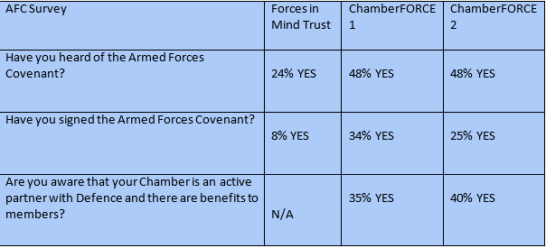

Fig 4.

26. In-Kind Support Leveraged. Participating Chambers, HRFCA and military buddies all put significant time resources into planning and delivering the 12-month pilot project. Over and above these core costs, military personnel involved in the project incurred additional man hours when delivering and hosting events. Estimates based on additional planning meetings for events, travel, personnel for leadership and ChamberSTRETCH activities, and hospitality have been put at £7,000. The cost of hiring Slessor Gardens in Dundee for the ChamberSTRETCH event would have been £1,000. This fee was waived by Dundee City Council as part of their Gold ERS support for the Armed Forces. There was thus £8,000 (+/-) of additional in-kind support generated by the project.

**Findings and Lessons Identified**

27. Findings. The pilot project found conclusively that working more closely with Chambers of Commerce, in a managed and mutually beneficial way, led to increased engagement activity with local businesses. As set out in this report, engagement activities, AFC signings and leads, and social media interaction, all increased when ChamberFORCE was used as a vehicle to promote the benefits of engaging with Defence. All participants reported a better understanding of each other’s respective work environments and challenges, and strong, pro-active partnerships (and friendships) were formed between the military and civilian buddies. Key findings are as follows:

a. **HRFCA** found that engaging via ChamberFORCE was more productive that with a range of Chambers on an ad hoc basis as previously and was able to better utilise membership benefits in terms of advertising, promotion and Chamber events. This delivered a better RoI in both time and money.

b. **Chambers of Commerce** found that engaging directly with a military buddy had been beneficial: *“...having our buddy as a single point of contact and someone we can ask daft civilian questions of and who helps us navigate the various events, terminology and ways of working from an armed forces perspective – that’s been invaluable*.” (CEO Dundee & Angus Chamber of Commerce). The project also reduced the number of multiple requests being put to Chambers by Defence; a problem identified by the Chamber CEOs at the scoping phase. (Reference A.)

c. **Defence partners** found that the project was creating *“a mutually beneficial environment where local businesses are better able to understand and exploit the economic potential of the Military presence in the region, whilst the wider Armed Forces community (Reserves, families and Service leavers) are benefitting from improved understanding and access to employment opportunities. ...a win-win situation.”*(XO Base Support Wing, RAF Lossiemouth). While acknowledging that the ChamberFORCE project is still in its early stages, the benefits of being able to access new audiences via the Chambers was found to *“have the potential in time to lead to a greater uptake in Armed Forces Covenant, improve employers’ understanding of the benefits that a Reservist of ex-regular can bring to the workplace…and in turn will assist in supporting routine recruiting activity.”* (RBM1 NRCSNI)

28. Lessons Identified. The following Lessons Identified (LI) emerged from the pilot project:

a. Communication between the participants was vital but it proved extremely difficult to get all of the project EG together for the quarterly meetings due to the pressure of work diaries and also geographical distance. Solutions were to use dial-in, for those non-attending to send written updates, and for minutes and actions to be disseminated quickly. These actions helped but did not always fully offset non-attendance, and communication will become more difficult to manage when other Chambers join the group.

b. Aberdeen & Grampian Chamber of Commerce decided to withdraw from the project as active partners at the end of the 12-month period, although committing to continue being supportive in a wider capacity. They felt that in their region and organisation, there was a need to focus on other priorities. This again underlines the point made at paragraph 16 that no one size fits all, and that all Chambers have to manage a wide range of services and projects to their members, with ChamberFORCE being one of many initiatives competing for time. It is anticipated that in a Phase 2 of the project, Aberdeen & Grampian would be replaced by Inverness Chamber and/or Ayrshire Chamber, both of whom have expressed an interest.

c. Managing a shared MEL proved to be difficult. With many partners involved, it was impossible for one central point of contact to coordinate all the information. The EG agreed that having a MEL is an important element of sharing best practice, and options are being considered for how to do this in any Phase 2.

**Recommendations and Next Steps**

29. Recommendations. In overall terms, the project is assessed as having achieved its stated outputs and thus offers an effective, efficient and workable model for further development. Subject to the agreement and endorsement of relevant parties, including DRM, it is therefore proposed that the project proceeds to a second phase, embracing the Findings and LIs set out above. Specific recommendations to be taken forward to Phase 2 of the project, and which reflect the Findings and LIs above, are as follows:

a. **Executive Group (EG) Communications**. The EG should establish a more efficient way of communicating when not able to meet in person. A software platform such as Slack or Microsoft Teams should be used to enable everyone to share developments and opportunities in between quarterly meetings.

b. **MEL**. The EG should find a suitable electronic platform to enable a shared calendar of events to be created and maintained.

c. **AFC Signatories**. Chambers which have signed the AFC and demonstrated a commitment to Defence should be encouraged to join the EG, with Ayrshire and Inverness already identified as possible new members. It is recommended that the increase in number of participants should be phased in order to keep the project manageable and on track, with no more than 3 Chambers and their respective partners joining in 2020.

d. **LinkedIn**. LinkedIn was not used to any significant extent during the pilot project but is considered important by the EG. It is recommended that a ChamberFORCE LinkedIn page and group should be set up, not only for the key stakeholders but also to encourage Armed Forces- friendly employers and self-employed Veterans to network with each other.

e. **Additional Options**. Additional options to be developed were put forward by the EG at the end of the pilot phase of the project. It is recommended that at least two of these: work placement attachments and mentoring be examined in more detail as potential benefits to be offered by the Chambers to the Defence partners.

f. **Lead Partner**. After consultation with SCC and the EG, it is recommended that SCC take over as lead partner of the ChamberFORCE project and brand and head up a bid to the Forces in Mind Trust for funding to support the project over the next 3 years.

30. Next Steps. The evaluation report will be submitted firstly to DRM as the pilot sponsor for comment and further discussion. Subsequently it will be made available to all via the HRFCA website, and in hard copy to members of the Scottish REEB. It is envisaged a further meeting with DRM will take place before the end of 2019 to discuss future plans and funding to allow the project to be rolled out in other parts of the UK. A funding bid will also be put to Forces in Mind Trust by Scottish Chambers of Commerce to enable them to assist with developing the next phase and to allow new Chambers in Scotland to participate. A meeting has been requested by Mr Graham Dey, MSP and Minister for Parliamentary Business and Veterans for the Scottish Government, for a brief on the project, and this will take place on November 22nd 2019.

M McKEARNON

Head of Engagement

HRFCA

Annexes:

A. Military Partners.

B. Project Deliverables

C. Evidence of Key Engagement Opportunities

D. ChamberFORCE Communications Plan

E. Infographic

ANNEX A to **HIGHLAND RFCA ChamberFORCE PROJECT – FINAL REPORT dated Oct 19**

**Military Partners**

* Dundee & Angus Chamber
* 225 Med Regt. (PoC WO1 Robert Wilson)
* Fife Chamber
* 154 Transport Regiment. (PoC Major Susan Duthie)
* Dunbartonshire Chamber of Commerce
* 7 Scots (PoC Alan McEwen)
* Aberdeen Chamber of Commerce
* NRCSNI (PoC Lt Cmdr Garth Atkinson)
* Moray Chamber of Commerce
* RAF Lossiemouth, XO Base Support Wing (PoC Sarah Riley-Evans)

NB: Due to Naval footprint in Scotland, RNR buddy worked with all Chambers where appropriate, although partnered with Aberdeen in terms of being PoC.

ANNEX B to **HIGHLAND RFCA ChamberFORCE PROJECT – FINAL REPORT dated Oct 19**

**Project Deliverables**

* Each Chamber will identify a single PoC (Point of Contact) who will attend quarterly Executive Group meetings hosted by HRFCA, either in person or remotely where possible. This does not need to be the Chief Exec – any Chamber member of member of its management team selected as the primary Armed Forces contact is acceptable. Each Chamber’s Armed Forces Ambassador will be invited to become an associate member of HRFCA, with the networking opportunities that brings.
* Each Chamber will host a linked webpage outlining the benefits of engaging with defence – content and financial resources to be provided by HRFCA.
* Each Chamber will send regular e-shots to their respective memberships – content and financial resources to be provided by HRFCA
* Each Chamber will stock hard copy promotional materials provided by HRFCA/DRM for distribution at events
* Each Chamber will be partnered with a “buddy” military unit with whom they can develop a relationship unique to the identified requirements of their own Chamber membership. This partnership is a key element of the project and should alleviate the problem of multiple requests for support which Chambers have suffered previously
* Chambers and the HRFCA will commit to actively supporting each other on social media with retweets, follows and likes for mutual promotion. HRFCA will encourage its business contacts to engage with their local Chamber if they don’t already do so.
* HRFCA will produce a menu of offerings and benefits including leadership training, events, speakers and so on, so that Chambers can be informed and be up to date on what the RFCA can offer.
* Chambers and HRFCA will jointly produce a Master Events List (MEL) so that there is advance notice of events and a reduction in diary conflict.
* Chambers represented in the Executive Group will be offered preferential access to those major defence activities and events which HRFCA is co-ordinating or hosting.
* New marketing materials produced by HRFCA around employer engagement benefits will carry the logos of participating Chambers.

ANNEX C to **HIGHLAND RFCA ChamberFORCE PROJECT – FINAL REPORT dated Oct 19**

**Key Engagement Activities**



**ANNEX D to HIGHLAND RFCA ChamberFORCE PROJECT – FINAL REPORT dated Oct 19**

**ChamberFORCE Communications Plan**

**Overview** -Chamber Force is a Chamber-led project designed to raise awareness of and advocacy for the benefits of engaging with Defence. This communications plan describes how the key messages of this project will be communicated to media and key stakeholders.

**Objectives**

* Increase awareness and advocacy among Scotland’s employers of the benefits of ….
* Drive awareness of the Release Scotland project, encouraging employers to sign up to the network and access the website

**Audiences**

* Public: dispelling myths and emphasising societal and economic positives
* Employers: encouraging engagement with Release Scotland and its messages
* Key stakeholders: demonstrating a coherent approach towards employing people with criminal convictions
* Media: provision of real life case studies (in line with releases used for Reserves day) and a Scotland-wide approach towards the promotion of employing people with an armed forces background.

**Channels**

* **Media releases**
  + National media launch on November 23rd (tbc) in partnership with Dundee City Council, supported by DRM comms team
  + Additional releases by partners/stakeholders as appropriate, to be co-ordinated by HRFCA comms team.
* **Social media engagement**
  + Partner & Stakeholder channels (managed by Partners)
  + Chamber Force Scotland Twitter account?
* **B2B channels**
  + SCC Business Scotland magazine (distribution 10,000, readership 30,000)
  + Quarterly page in Highlight Magazine, produced by HRFCA
  + Partner & Stakeholder Newsletters
  + Business publications eg Business Insider & The Courier Business Magazine

**Key Messages**

* Recruiting people with an armed forces background is good for society and good for the economy
* Armed Forces personnel are highly trained and multi-skilled. These skills are transferable into the business world.
* People with armed forces backgrounds offer commitment, discipline and a can do attitude which makes them positive role models in the workforce.

ANNEX E to **HIGHLAND RFCA ChamberFORCE PROJECT – FINAL REPORT dated Oct 19**

**Infographic**

